Design Artefact Diagram

Product Registration and Authentication Application

CS-208

BY:

Varsha Dhakad

Shubham Goyal

Apoorv Kulshrestha

Rahul Kumar Keshri

Submitted to:

Dr Abhishek Srivastava

1.Context Model

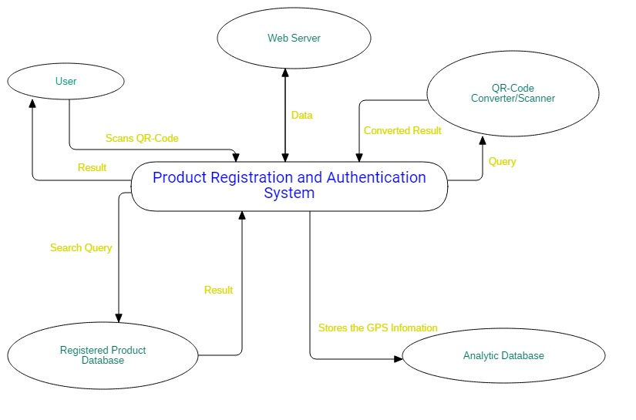

-------------------------------------------------------------

2.Class Diagram

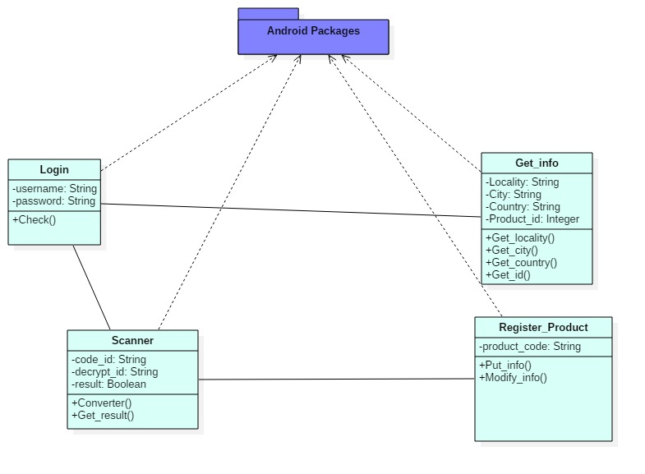

-------------------------------------------------------------

3.Interaction Model

a. Use Case Diagram

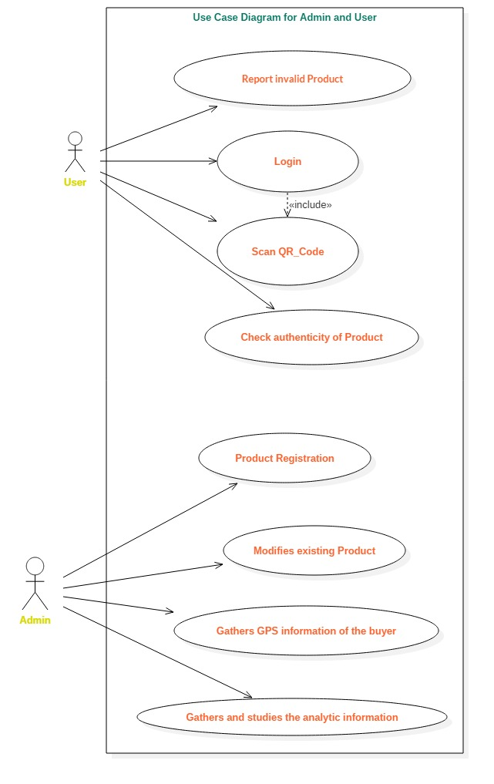

b. Sequence Diagram

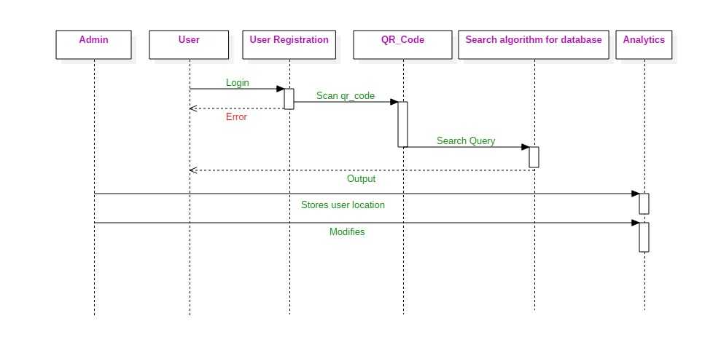

-------------------------------------------------------------

4. Behavioural Model

a.Data Flow Diagram



